
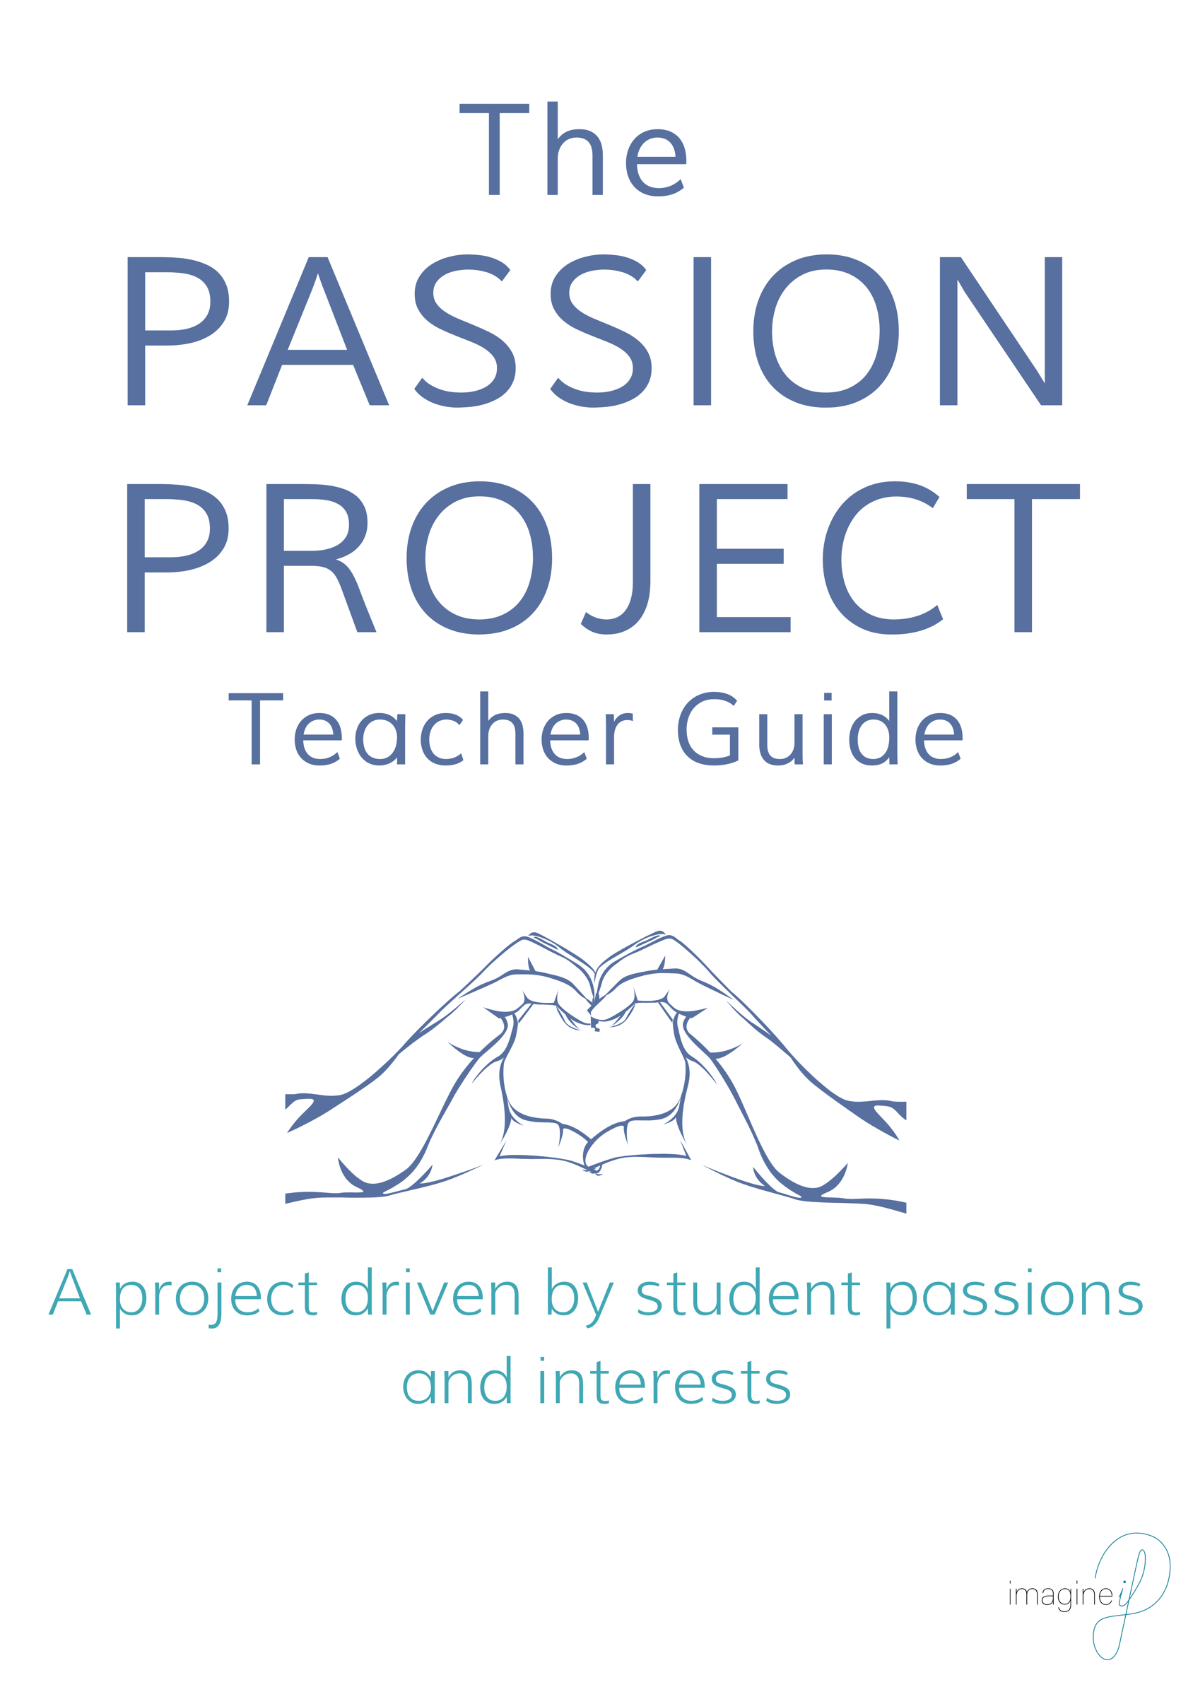


Passion Project
Teacher Guide

Passion Projects are a great way to give students ownership and choice over what they’re learning while still using a structured Project-Based Learning process. The Passion Project is ideal for remote or on-line learning and can also be used in normal classrooms.

In addition to student-driven academic learning, they will also learn the following real-world skills:
- Time management
- Collaboration
- Giving/receiving feedback
- Self-Discipline
- Critical thinking
- Self-reliance
- Learning to learn

Time
The Student Toolbox walks students through the process of doing a Passion Project over four weeks, but this time can be shortened or lengthened without impacting the process or the project.

Parents
We recommend sending home a Parent Letter that outlines the purpose of the Passion Project, the timeline/deadlines and some useful pieces of advice about how they can help. See “Sample Parent Letter” for some ideas.

Increasing Academic Rigor
The goal of the passion project is to give students maximum choice and ownership over their learning, so be careful not to disrupt this by adding unnecessary academic requirements. The rigor of the Passion Project can be increased by:
- Giving students a subject and having them choose a topic within it
- Giving students a BIG Question, or options to choose from
- Having students align their topics/BIG Questions to the UN Sustainable Development Goals
- Giving students a specific UN Sustainable Development Goal and having them choose a topic and question within it

Online Learning Platform
The Passion Project is ideal for remote/online learning because it is flexible, student-driven and owned by students. The use of an Online Learning Platform (Microsoft TEAMS, Google Classroom, Flipgrid, MeeBook, etc.) can facilitate student collaboration, teacher Check-In’s and increase accountability to be sure all students are on track. If an Online Learning Platform is not an option to use with the Passion Project, Check-In’s can still be done via phone, email or social media.

Critical Friends
This version of the Passion Project has students collaborating with a Critical Friend 2-3 times during the project. The Critical Friend is someone who can give/receive feedback on the project, and also support the student if they have challenges. Critical Friends should be paired before the project begins so their contact information can be exchanged.

Adapting For Younger Students
This version of the Passion Project is made for middle to high school students who can read, write and reasonably follow directions on their own. Adaptions can be made for younger students or students who do not fit these descriptions by offering a simplified version of each step. It is also possible to print the Student Toolbox so students can hand-write their work rather than documenting electronically. Instead of online research, students can check-out books relating to their topics or be provided with a list of websites or videos to help them in the research process. If the Passion Project is being done at home, family members can give feedback to the student in place of the teacher or Critical Friend. In the CRITIQUE phase, simply replace the word “teacher” with family member so the feedback can still be documented.

Launch Phase
It might be helpful to complete the Launch Phase as a class before any kind of remote or online learning takes place. Getting kids excited about the Passion Project is key for sustaining their interest over a longer period of time, especially if it is not possible for students to meet in person.

There are many versions of the Passion Project that exist for teachers to use. This version has been developed by Imagine If with inspiration from the following educators:

- Evelyn McCullough (Park Maitland School, Director of Teaching and Learning)
- Kyle Wagner (Transform Educational Consulting, Founder)

You are welcome to use, change and share this version of Passion Project so it fits your students and your needs.

For more ideas to use with Project-Based Learning, visit www.imagineif.dk


